Below is a screenshot of the one visual that will not show up in the HTML file.

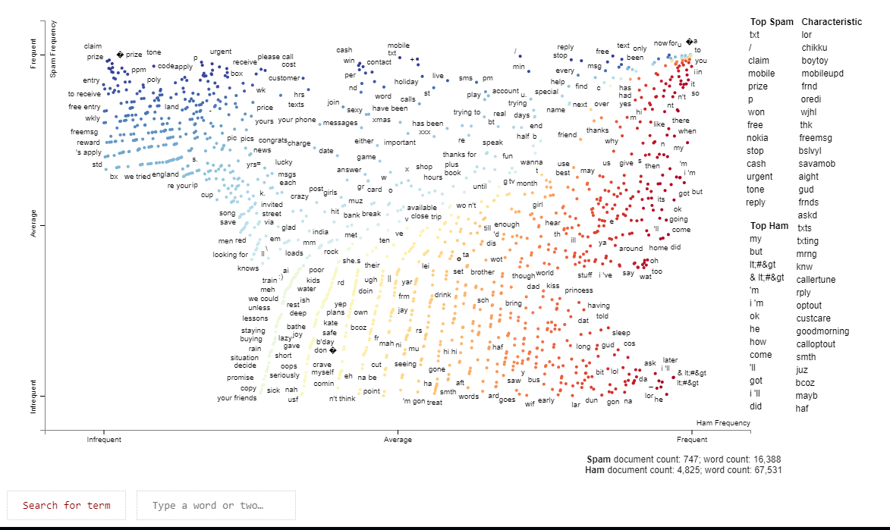

This is a link to the collab.

https://colab.research.google.com/drive/1cIEw6FhOnN9C6kMK4tujVOVQdtKvcQVa